**“UTS Genap”**



**Untuk Memenuhi UTS Genap Tahun Ajaran 2019/2020**

**Mata Kuliah Pemrograman Komputer 2**

**Dosen Pengampu: M. Nishom., M.Kom**

**Disusun Oleh:**

**AISATUL MUTOHAROH**

**NIM: 18090107**

**KELAS 4D**

**PRODI D4 TEKNIK INFORMATIKA**

**POLITEKNIK HARAPAN BERSAMA**

**TEGAL**

**2020**

**MANUAL BOOK ARSIP DOKUMENTASI**

1. Membuat Data Base

* Buka xampp kemudian aktifkan Apache dan My sql dan pilih admin untuk masuk ke php my admin
* Kemudian buat basis data seperti di bawah ini :

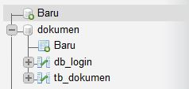

* Bagian db_login :

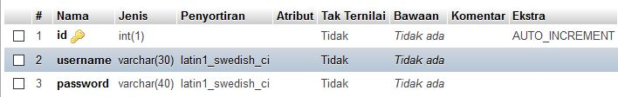

* Bagian tb_dokumen :

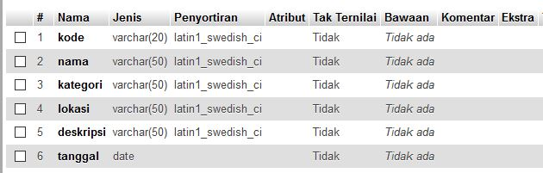

1. Menyiapkan Project

* Buka Netbeans, kemudian klik **file** pada pojok kiri atas lalu pilih **new project**.

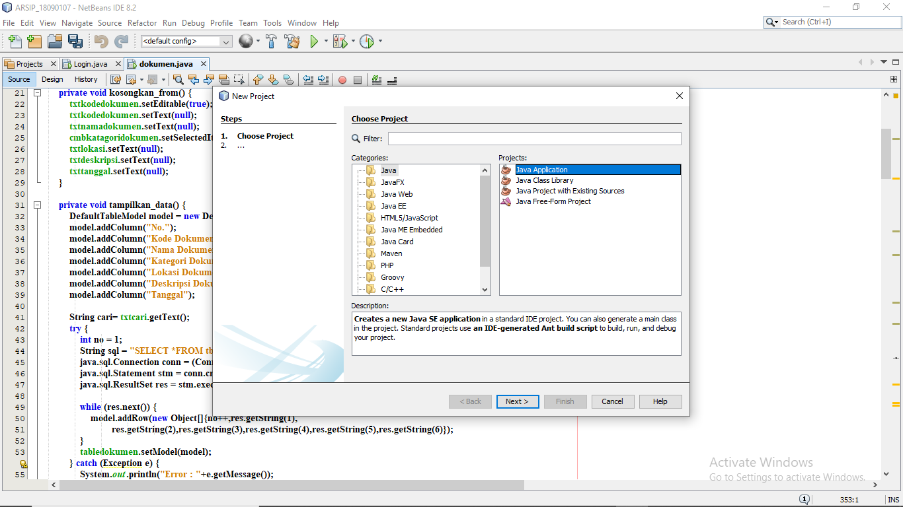

Setelah jendela terbuka seperti ini pilih java applications lalu klik next>>

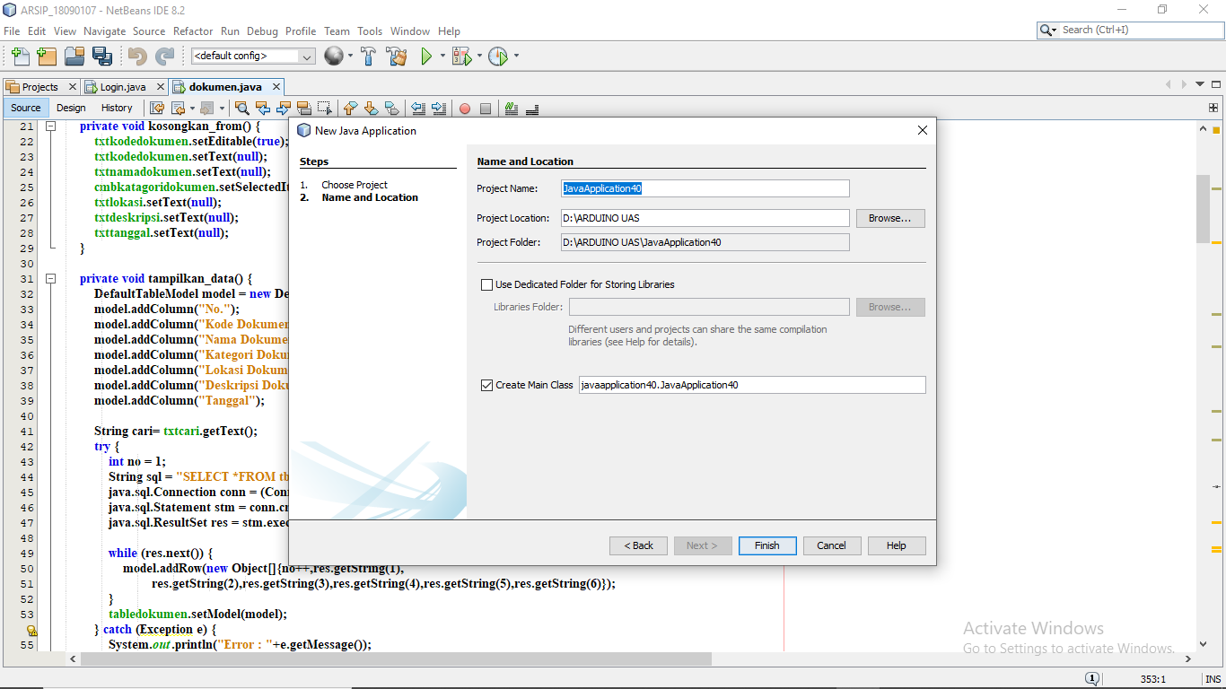

Pada project name ketikkan **Dokumen** lalu pada project locations pilihlah lokasi sesuai dengan keinginan Anda, setelahnya klik finish. Pada chek box disamping Create Main Class hilangkan tanda centang

* Setelah membuat project baru, buatlah package baru dengan nama Apps

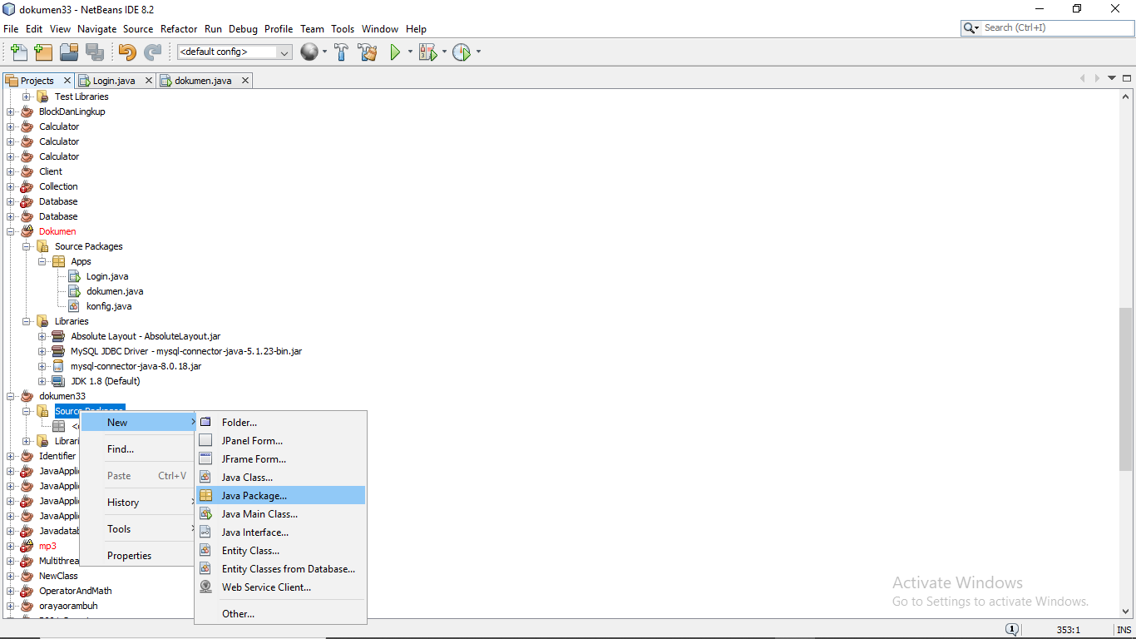

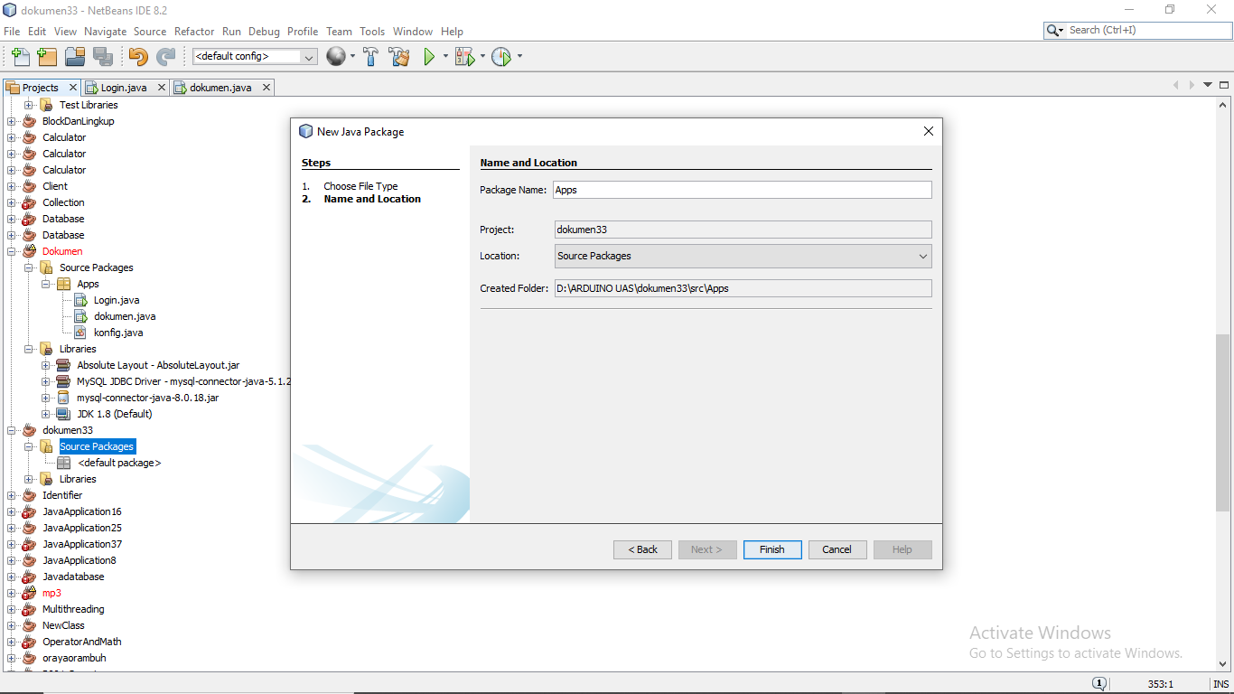

Pada package name ketikkan Apps, setelahnya **finish**

1. Membuat kelas

* Didalam package Apps buatlah class konfig dan buat Jframe Login dokumen

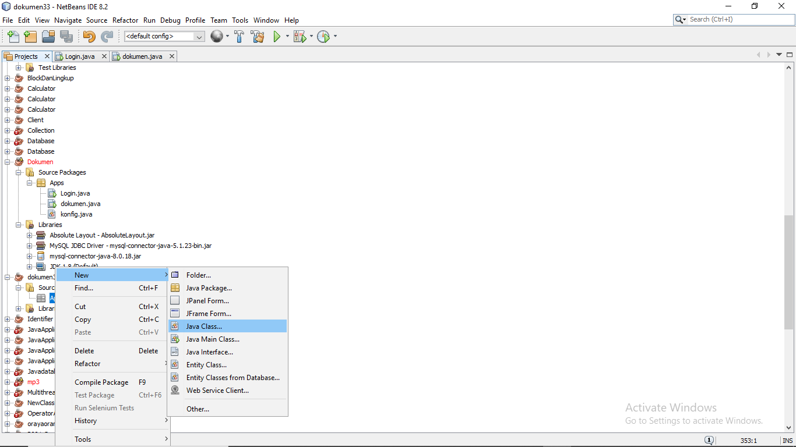

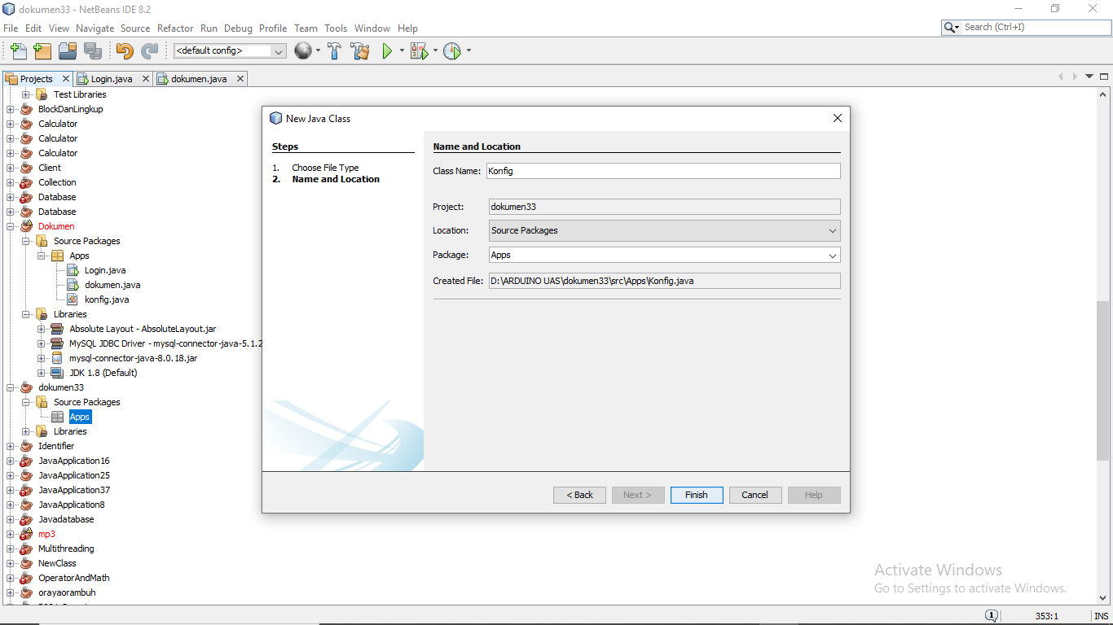

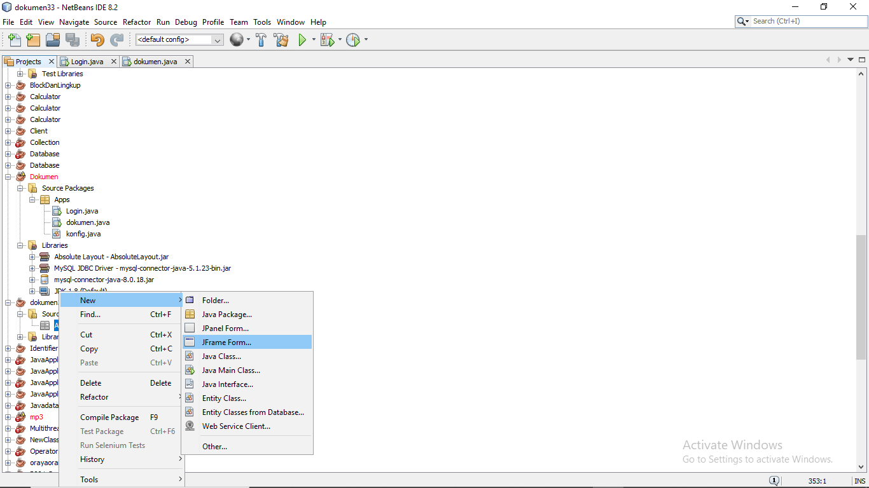

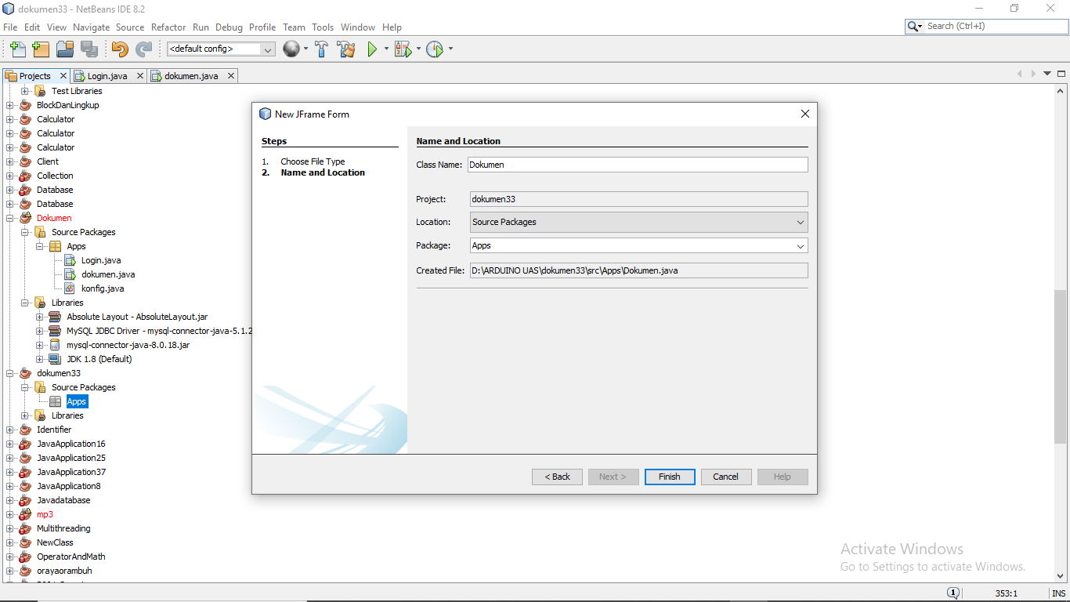

Isikan **dokumen** pada Class name

* Class konfig untuk menyambungkan data base, kemudian di class konfig di isi :

package Apps;

import java.sql.Connection;

import java.sql.DriverManager;

import java.sql.SQLException;

public class konfig {

private static Connection MySQLConfig;

public static Connection configDB () throws SQLException{

try {

String url = "jdbc:mysql://localhost:3306/dokumen";

String user = "root";

String pass = "";

DriverManager.registerDriver(new com.mysql.jdbc.Driver());

MySQLConfig = DriverManager.getConnection(url , user , pass);

} catch (Exception e) {

System.out.println("Koneksi Ke Database Gagal"+e.getMessage());

}

return MySQLConfig;

}

}

1. Jframe

* Membuat Jframe Login :

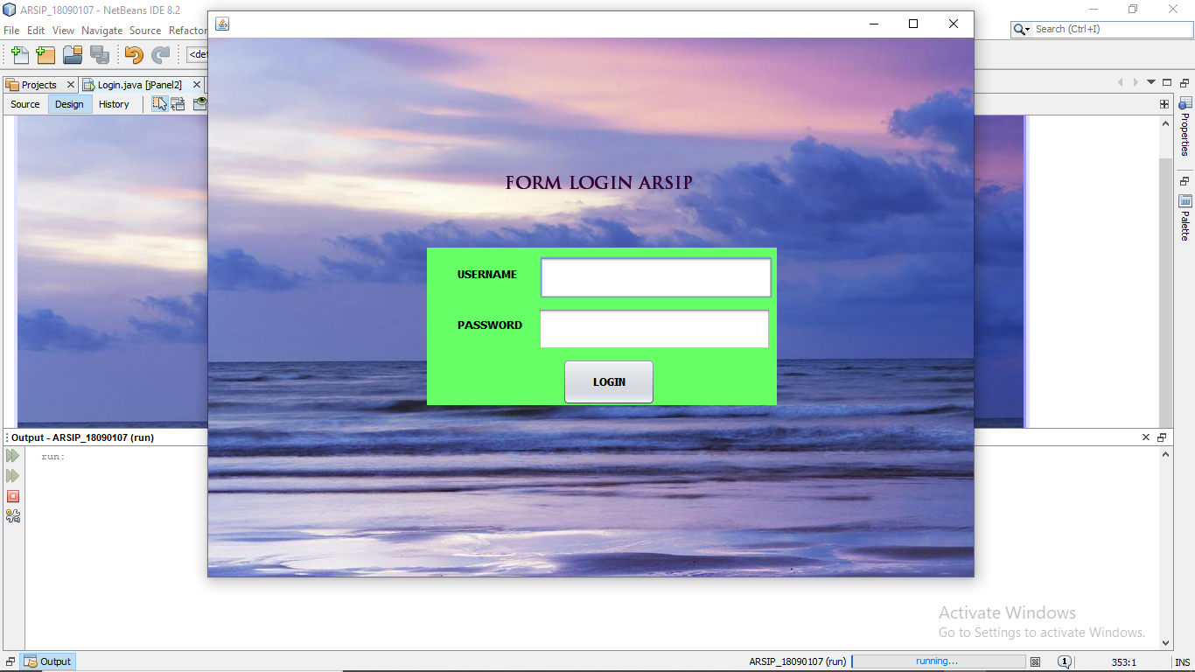

* Kemudian import seperti ini :

package Apps;

import java.awt.Frame;

import java.security.MessageDigest;

import java.security.NoSuchAlgorithmException;

import java.sql.Connection;

import java.sql.ResultSet;

import java.sql.Statement;

import javax.swing.JOptionPane;

public class Login extends javax.swing.JFrame {

public Login() {

initComponents();

}

private void txtusernameActionPerformed(java.awt.event.ActionEvent evt) {

}

private void txtpasswordActionPerformed(java.awt.event.ActionEvent evt) {

}

private void btnloginActionPerformed(java.awt.event.ActionEvent evt) {

doLogin();

}

public static void main(String args[]) {

java.awt.EventQueue.invokeLater(new Runnable() {

public void run() {

Login login = new Login();

login.setExtendedState(Frame.MAXIMIZED_BOTH);

login.setVisible(true);

}

});

}

private javax.swing.JButton btnlogin;

private javax.swing.JLabel jLabel1;

private javax.swing.JLabel jLabel2;

private javax.swing.JLabel jLabel3;

private javax.swing.JPanel jPanel1;

private javax.swing.JPanel jPanel2;

private javax.swing.JPanel jPanel3;

private javax.swing.JSeparator jSeparator1;

private javax.swing.JPasswordField txtpassword;

private javax.swing.JTextField txtusername;

public void doLogin() {

btnlogin.setEnabled(false);

String user = txtusername.getText();

char[] pass = txtpassword.getPassword();

if (user.isEmpty()) {

JOptionPane.showMessageDialog(this, "Username harus diisi");

txtusername.requestFocus();

} else if (pass.length == 0) {

JOptionPane.showMessageDialog(this, "Password harus diisi");

txtpassword.requestFocus();

} else {

String password = new String(pass);

String md5_pass = md5(password);

try {

Connection c = konfig.configDB();

Statement st = c.createStatement();

String q = " SELECT * FROM db_login "

+ "WHERE username = '" + user + "' "

+ "AND password = '" + md5_pass + "'";

ResultSet rs = st.executeQuery(q);

int n = 0;

while (rs.next()) {

String u = rs.getString("username");

String p = rs.getString("password");

n++;

}

if (n == 0) {

JOptionPane.showMessageDialog(this, "Username/password salah!");

txtusername.requestFocus();

btnlogin.setEnabled(true);

} else {

dokumen kar = new dokumen();

this.setVisible(false);

kar.setExtendedState(Frame.MAXIMIZED_BOTH);

kar.setVisible(true);

}

} catch (Exception e) {

System.out.println(e.getMessage());

}

}

}

public static String md5(String data) {

String hashed = "";

try {

MessageDigest md5 = MessageDigest.getInstance("MD5");

md5.update(data.getBytes());

byte[] byteData = md5.digest();

StringBuilder sb = new StringBuilder();

for (int i = 0; i < byteData.length; i++) {

sb.append(Integer.toString((byteData[i] & 0xff)

+ 0x100, 16).substring(1));

}

hashed = sb.toString();

} catch (NoSuchAlgorithmException e) {

}

return hashed;

}

}

* Membuat JFrame dokumen :

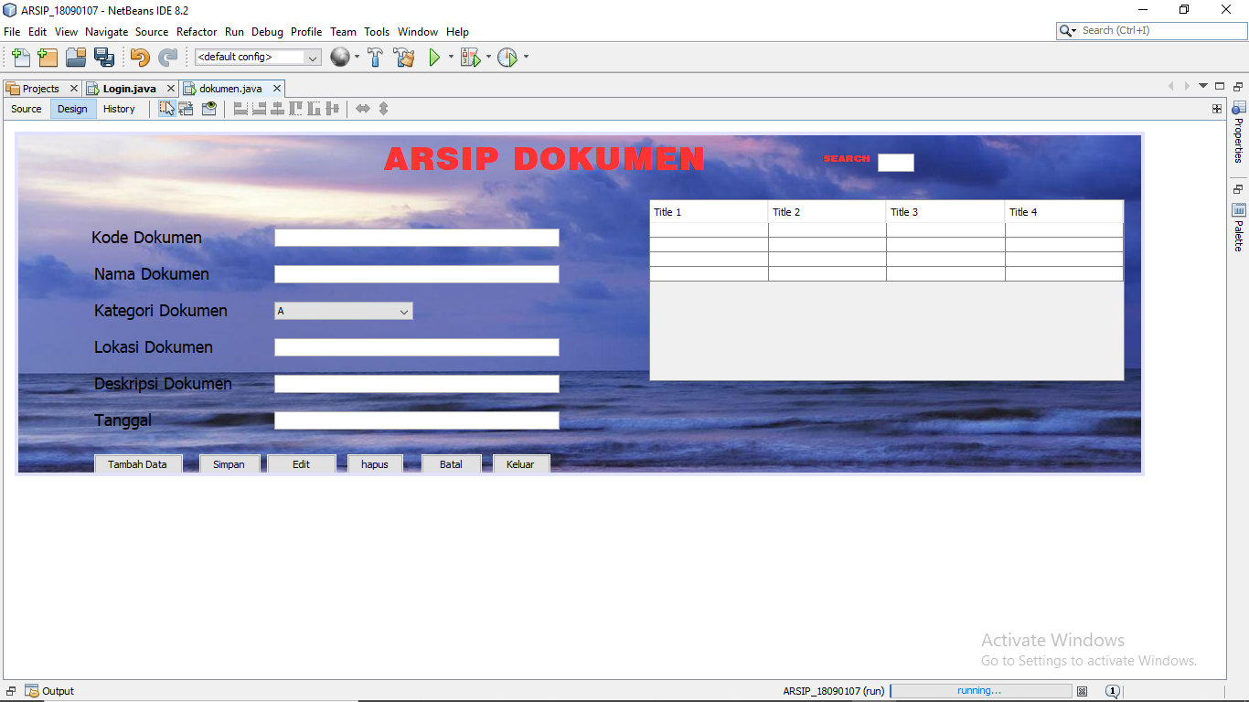

package Apps;

import java.awt.HeadlessException;

import java.sql.Connection;

import java.sql.SQLException;

import javax.swing.JOptionPane;

import javax.swing.table.DefaultTableModel;

public class dokumen extends javax.swing.JFrame {

private void kosongkan_from() {

txtkodedokumen.setEditable(true);

txtkodedokumen.setText(null);

txtnamadokumen.setText(null);

cmbkatagoridokumen.setSelectedItem(this);

txtlokasi.setText(null);

txtdeskripsi.setText(null);

txttanggal.setText(null);

}

private void tampilkan_data() {

DefaultTableModel model = new DefaultTableModel();

model.addColumn("No.");

model.addColumn("Kode Dokumen");

model.addColumn("Nama Dokumen");

model.addColumn("Kategori Dokumen");

model.addColumn("Lokasi Dokumen");

model.addColumn("Deskripsi Dokumen");

model.addColumn("Tanggal");

String cari= txtcari.getText();

try {

int no = 1;

String sql = "SELECT *FROM tb_dokumen WHERE nama LIKE '%"+cari+"%' ";

java.sql.Connection conn = (Connection)konfig.configDB();

java.sql.Statement stm = conn.createStatement();

java.sql.ResultSet res = stm.executeQuery(sql);

while (res.next()) {

model.addRow(new Object[]{no++,res.getString(1),

res.getString(2),res.getString(3),res.getString(4),res.getString(5),res.getString(6)});

}

tabledokumen.setModel(model);

} catch (Exception e) {

System.out.println("Error : "+e.getMessage());

}

}

public dokumen() {

initComponents();

tampilkan_data();

kosongkan_from();

}

private void btnBatalActionPerformed(java.awt.event.ActionEvent evt) {

kosongkan_from();

}

private void btnKeluarActionPerformed(java.awt.event.ActionEvent evt) {

System.exit(0);

}

private void btnTambahDataActionPerformed(java.awt.event.ActionEvent evt) {

try {

String sql = "INSERT INTO tb_dokumen VALUES ('"+txtkodedokumen.getText()+"','"+txtnamadokumen.getText()+"','"+cmbkatagoridokumen.getSelectedItem()+"','"+txtlokasi.getText()+"','"+txtdeskripsi.getText()+"','"+txttanggal.getText()+"')";

java.sql.Connection conn = (Connection)konfig.configDB();

java.sql.PreparedStatement pstm = conn.prepareStatement(sql);

pstm.execute();

JOptionPane.showMessageDialog(null, "Proses simpan Data berhasil");

tampilkan_data();

kosongkan_from();

} catch (HeadlessException | SQLException e) {

JOptionPane.showMessageDialog(this, e.getMessage());

}

txtkodedokumen.setFocusable(true);

}

private void btnSiimpanActionPerformed(java.awt.event.ActionEvent evt) {

try {

String sql = "INSERT INTO tb_dokumen VALUES ('"+txtkodedokumen.getText()+"','"+txtnamadokumen.getText()+"','"+cmbkatagoridokumen.getSelectedItem()+"','"+txtlokasi.getText()+"','"+txtdeskripsi.getText()+"','"+txttanggal.getText()+"')";

java.sql.Connection conn = (Connection)konfig.configDB();

java.sql.PreparedStatement pstm = conn.prepareStatement(sql);

pstm.execute();

JOptionPane.showMessageDialog(null, "Proses simpan Data berhasil");

tampilkan_data();

kosongkan_from();

} catch (HeadlessException | SQLException e) {

JOptionPane.showMessageDialog(this, e.getMessage());

}

}

private void tabledokumenMouseClicked(java.awt.event.MouseEvent evt) {

int baris = tabledokumen.rowAtPoint(evt.getPoint());

String nik = tabledokumen.getValueAt(baris, 1).toString();

txtkodedokumen.setText(nik);

String nama = tabledokumen.getValueAt(baris, 2).toString();

txtnamadokumen.setText(nama);

String jab = tabledokumen.getValueAt(baris, 3).toString();

cmbkatagoridokumen.setSelectedItem(jab);

String alamat = tabledokumen.getValueAt(baris, 4).toString();

txtlokasi.setText(alamat);

String email = tabledokumen.getValueAt(baris, 5).toString();

txtdeskripsi.setText(email);

String telp = tabledokumen.getValueAt(baris, 6).toString();

txttanggal.setText(telp);

}

private void btnEditActionPerformed(java.awt.event.ActionEvent evt) {

try {

String sql = "UPDATE tb_dokumen SET kode = '"+txtkodedokumen.getText()+"',nama = '"+txtnamadokumen.getText()+"',kategori = '"+cmbkatagoridokumen.getSelectedItem()+"',lokasi = '"+txtlokasi.getText()+"',deskripsi = '"+txtdeskripsi.getText()+"',tanggal = '"+txttanggal.getText()+"' WHERE kode = '"+txtkodedokumen.getText()+"'";

java.sql.Connection conn = (Connection)konfig.configDB();

java.sql.PreparedStatement pstm = conn.prepareStatement(sql);

pstm.execute();

JOptionPane.showMessageDialog(null, "Edit Data Berhasil");

} catch (HeadlessException | SQLException e) {

JOptionPane.showMessageDialog(this, e.getMessage());

}

tampilkan_data();

kosongkan_from();

}

private void btnHapusActionPerformed(java.awt.event.ActionEvent evt) {

try {

String sql = "DELETE FROM tb_dokumen WHERE kode = '"+txtkodedokumen.getText()+"'";

java.sql.Connection conn = (Connection)konfig.configDB();

java.sql.PreparedStatement pstm = conn.prepareStatement(sql);

pstm.execute();

JOptionPane.showMessageDialog(null, "Hapus Data Berhasil");

} catch (HeadlessException | SQLException e) {

JOptionPane.showMessageDialog(this, e.getMessage());

}

tampilkan_data();

kosongkan_from();

}

private void txtcariActionPerformed(java.awt.event.ActionEvent evt) {

}

private void txtcariKeyPressed(java.awt.event.KeyEvent evt) {

tampilkan_data();

}

private void txtnamadokumenActionPerformed(java.awt.event.ActionEvent evt) {

}

public static void main(String args[]) {

java.awt.EventQueue.invokeLater(new Runnable() {

public void run() {

new dokumen().setVisible(true);

}

});

}

private javax.swing.JButton btnBatal;

private javax.swing.JButton btnEdit;

private javax.swing.JButton btnHapus;

private javax.swing.JButton btnKeluar;

private javax.swing.JButton btnSiimpan;

private javax.swing.JButton btnTambahData;

private javax.swing.JComboBox<String> cmbkatagoridokumen;

private javax.swing.JLabel jLabel1;

private javax.swing.JLabel jLabel2;

private javax.swing.JLabel jLabel3;

private javax.swing.JLabel jLabel4;

private javax.swing.JLabel jLabel5;

private javax.swing.JLabel jLabel6;

private javax.swing.JLabel jLabel7;

private javax.swing.JLabel jLabel8;

private javax.swing.JLabel jLabel9;

private javax.swing.JScrollPane jScrollPane1;

private javax.swing.JTable tabledokumen;

private javax.swing.JTextField txtcari;

private javax.swing.JTextField txtdeskripsi;

private javax.swing.JTextField txtkodedokumen;

private javax.swing.JTextField txtlokasi;

private javax.swing.JTextField txtnamadokumen;

private javax.swing.JTextField txttanggal;

}

* JFrane login

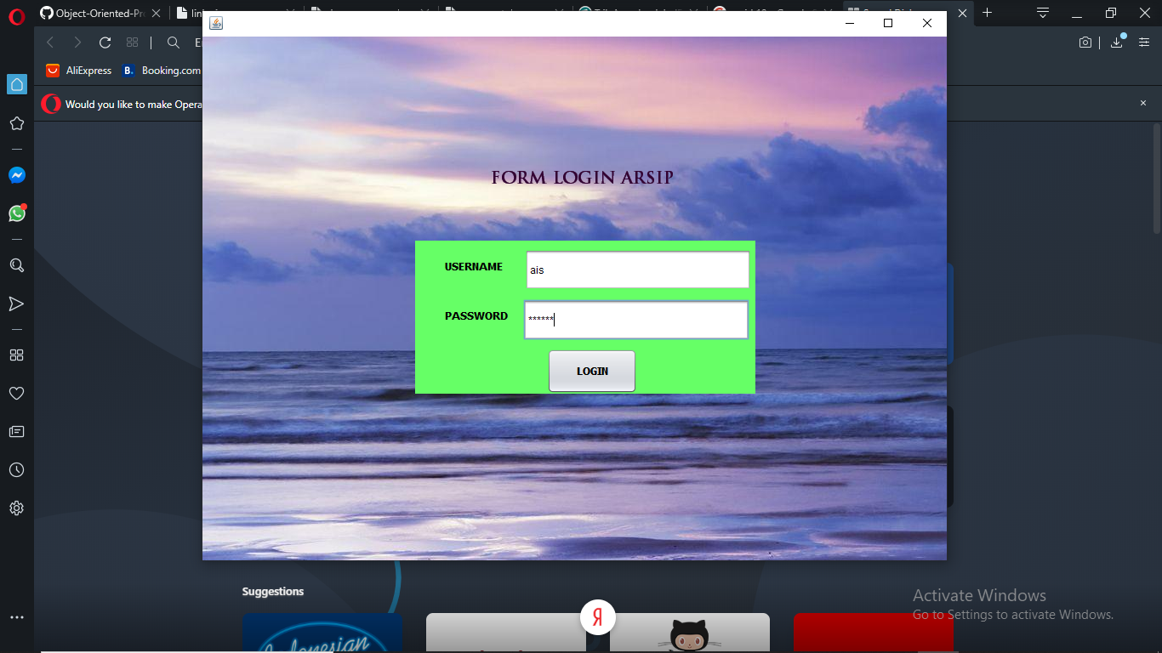

* Hasil login

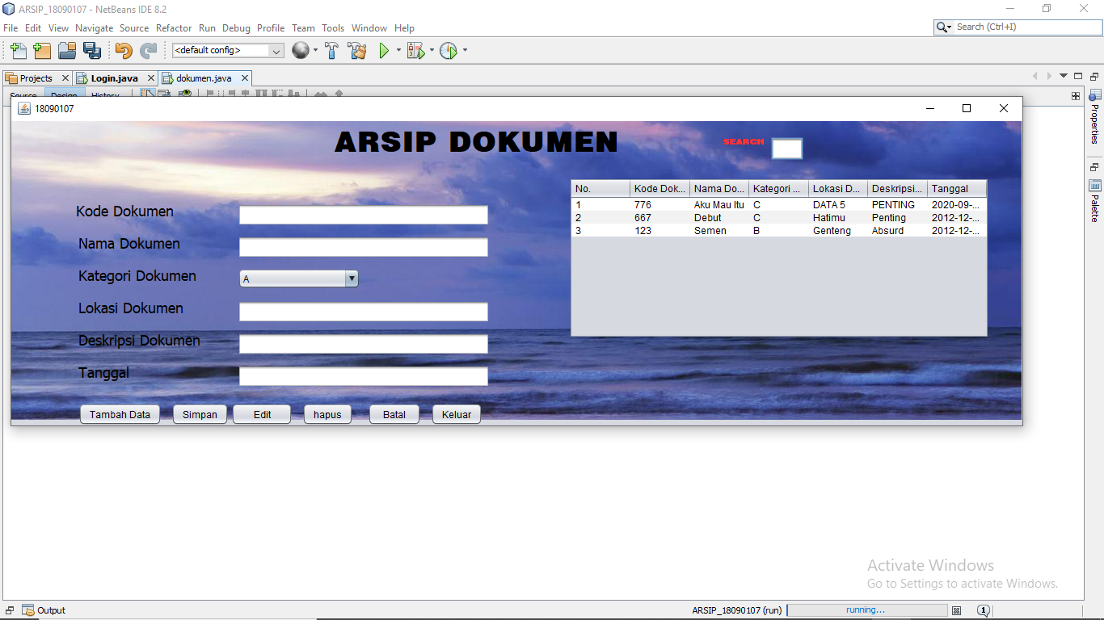

* Tambah data

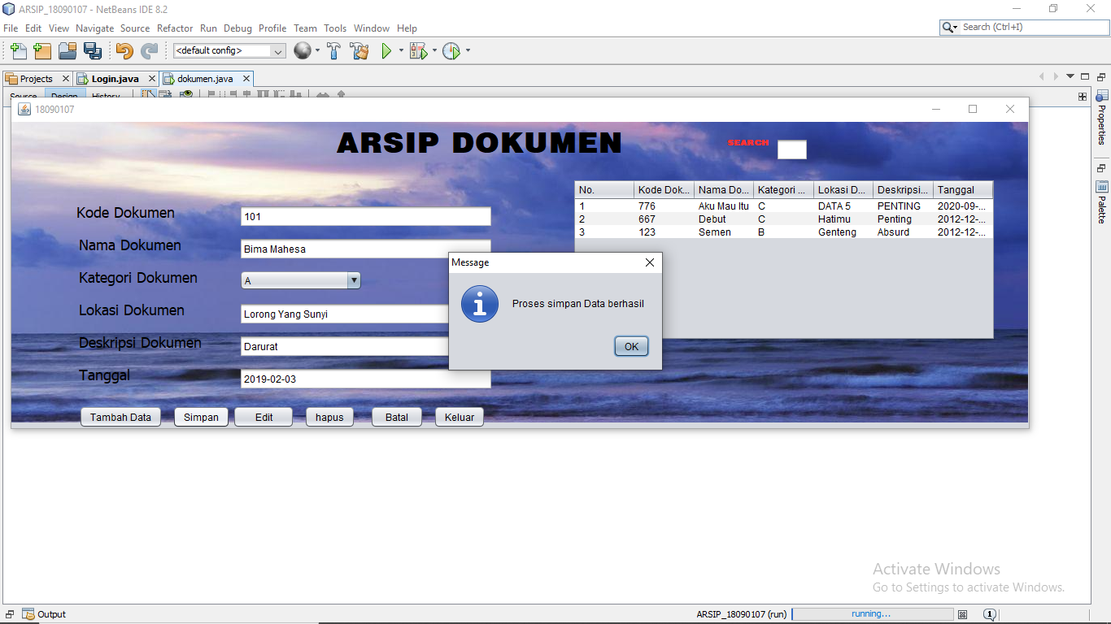

* Edit data

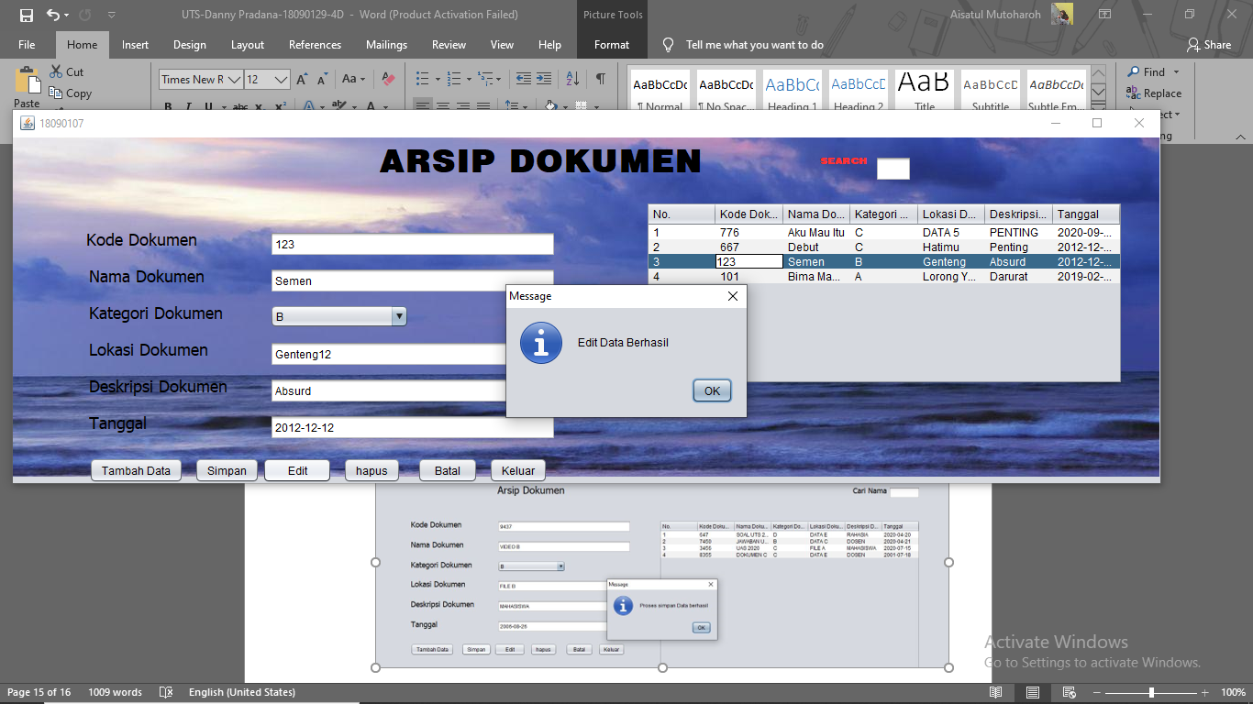

* Hapus data

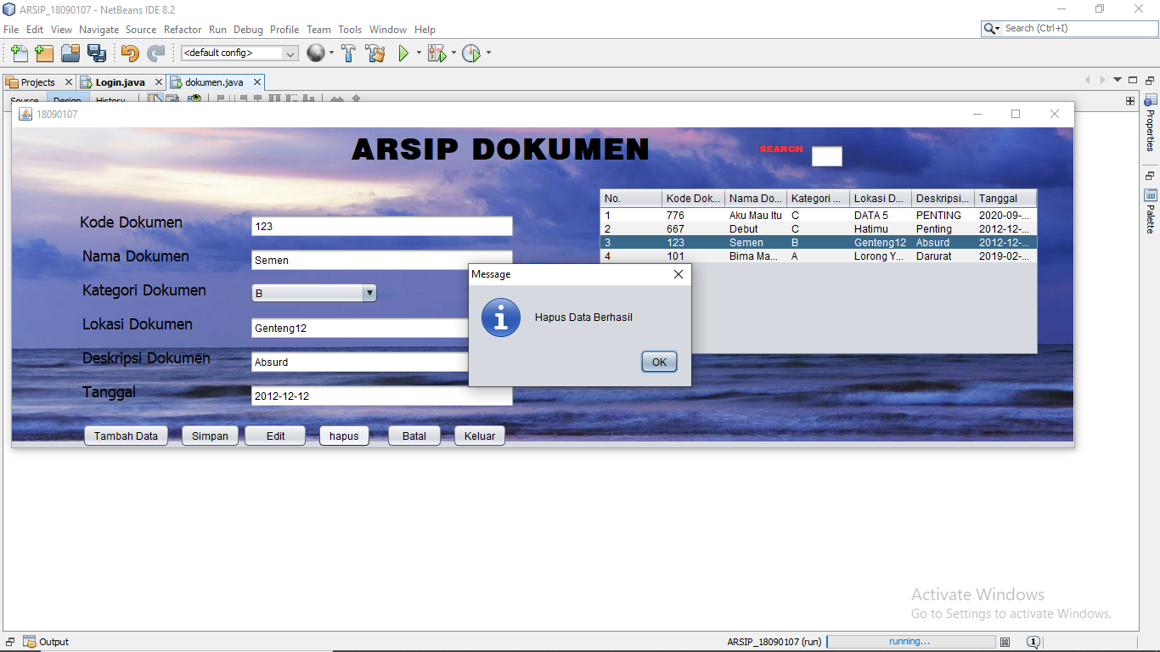

Link GitHub : <https://github.com/DannyPradana26/UTS_PK2>